**Nama : Muhamad Yazid Imani**

**Kelas : INF – A2**

**NIM : J0303211068**

**2.) Gunakan algoritma Djikstra’s dalam menentukan shorthest path dari graph pada gambar berikut :**

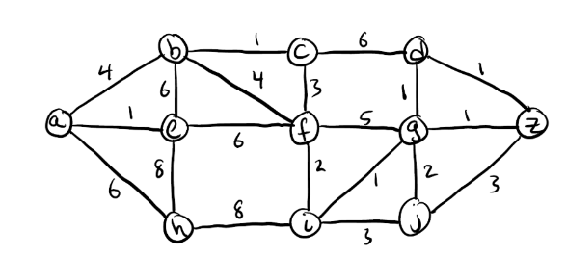

Jawab :

|  |  |  |  |  |  |  |  |  |  |  |  |  |  |  |  |
| --- | --- | --- | --- | --- | --- | --- | --- | --- | --- | --- | --- | --- | --- | --- | --- |
| i | S’ | S | u | du | da | db | dc | dd | de | df | dg | dh | di | dj | dz |
| - | {a,b,c,d,e,f,g,h,i,j,z} | {} | - | - | 0 | th | th | th | th | th | th | th | th | th | th |
| 1 | {b,c,d,e,f,g,h,i,j,z} | {a} | a | 0 | 0 | 4 | th | th | 1 | th | th | 6 | th | th | th |
| 2 | {b,c,d,f,g,h,i,j,z} | {a,e} | e | 1 | 0 | 4 | th | th | 1 | 7 | th | 6 | th | th | th |
| 3 | {c,d,f,g,h,i,j,z} | {a,e,b} | b | 4 | 0 | 4 | 5 | th | 1 | 7 | th | 6 | th | th | th |
| 4 | {d,f,g,h,i,j,z} | {a,e,b,c} | c | 5 | 0 | 4 | 5 | 11 | 1 | 7 | th | 6 | th | th | th |
| 5 | {d,f,g,i,j,z} | {a,e,b,c,h} | h | 6 | 0 | 4 | 5 | 11 | 1 | 7 | th | 6 | 14 | th | th |
| 6 | {d,g,i,j,z} | {a,e,b,c,h,f} | f | 7 | 0 | 4 | 5 | 11 | 1 | 7 | 12 | 6 | 9 | th | th |
| 7 | {d,g,j,z} | {a,e,b,c,h,f,i} | i | 9 | 0 | 4 | 5 | 11 | 1 | 7 | 10 | 6 | 9 | 12 | th |
| 8 | {g,j,z} | {a,e,b,c,h,f,i,d} | g | 10 | 0 | 4 | 5 | 11 | 1 | 7 | 10 | 6 | 9 | 12 | 11 |
| 9 | {j,z} | {a,e,b,c,h,f,i,d,g} | d | 11 | 0 | 4 | 5 | 11 | 1 | 7 | 10 | 6 | 9 | 12 | 11 |
| 10 | {j} | {a,e,b,c,h,f,i,d,g,j} | z | 11 | 0 | 4 | 5 | 11 | 1 | 7 | 10 | 6 | 9 | 12 | 11 |
| 1 | {} | {a,e,b,c,h,f,i,d,g,j,z} | j | 12 | 0 | 4 | 5 | 11 | 1 | 7 | 10 | 6 | 9 | 12 | 11 |